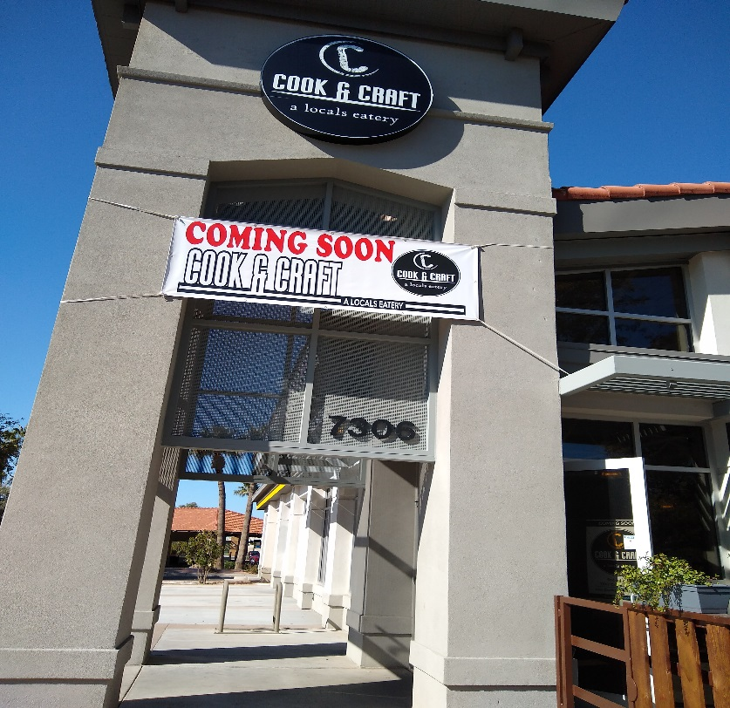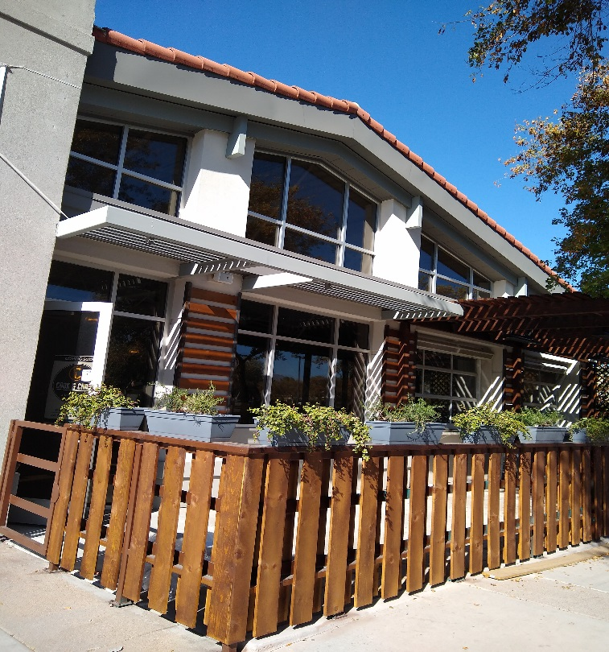

Lunch Cook & Craft with the team in February

We found this great place by accident, it will be opening for business on 2/19/2020. And DA will be their first club to host a group event with them.
Cook & Craft will featuring a variety of American Culinary delights, Vegan, Vegetarian, and selections to tempt all of us carnivores. Along with a wide variety of craft beers.

Please join your DA friends on February 22, 2020 @ 11:30 for lunch
Village At Shea – 7306 E. Shea Blvd,. Scottsdale, AZ 85254

If you have any questions, please contact cjdahlke@gmail.com

